**Unearthing the Environmental Impact of Human Activity:**

**A Global CO2 Emission Analysis**

1. **INTRODUCTION:**
   1. **Overview:**

Global warming is one of the biggest challenges currently being faced by the human race, although correlation is not causation, a likely cause of global warming is due to increased atmospheric carbon dioxide from human activities. CO2 Emission refers to the Carbon Dioxide emitted throughout the world. For this analysis we will be focusing on CO2 Emissions and its effect on the world we live in as well as some key factors and stats that may play a role in the emission of CO2 globally. Fossil fuel use is the primary source of CO2. The data throws light onto how much fossil fuels are burnt, per year per nation, which amounts to an increase in CO2 every year. This will help researchers and environment experts to predict global warming. So countries should set a goal to decrease this

amount yearly. Analysing Global Co2 Emission across countries from 1975 to 2020. This dataset contains a record of Co2 Emission by each Country and Region of Earth, here we are going to analyse and visualise Country wise, Region wise and Overall Co2 Emission on Earth.

* 1. **Purpose:**

* The production of CO2-based fuels and chemicals is energy-intensive and requires large amounts of hydrogen. The carbon in CO2 enables the conversion of hydrogen into a fuel that is easier to handle and use, for example as an aviation fuel. CO2 can also replace fossil fuels as a raw material in chemicals and polymers.
* **Globally, some 230 million tonnes (Mt) of carbon dioxide (CO2) are used every year.** The largest consumer is the fertiliser industry, where 130 Mt CO2 is used in urea manufacturing, followed by oil and gas, with a consumption of 70 to 80 Mt CO2 for enhanced oil recovery. Other commercial applications include food and beverage production, metal fabrication, cooling, fire suppression and stimulating plant growth in greenhouses. Most commercial applications today involve direct use of CO2.
* Land use and transportation planning have a long-term and structural role in shaping the built environment, which has a profound impact on people's daily work, life and travel.

**2.PROBLEM SOLVING AND DESIGN THINKING:**

**2.1 Empathy Map:**

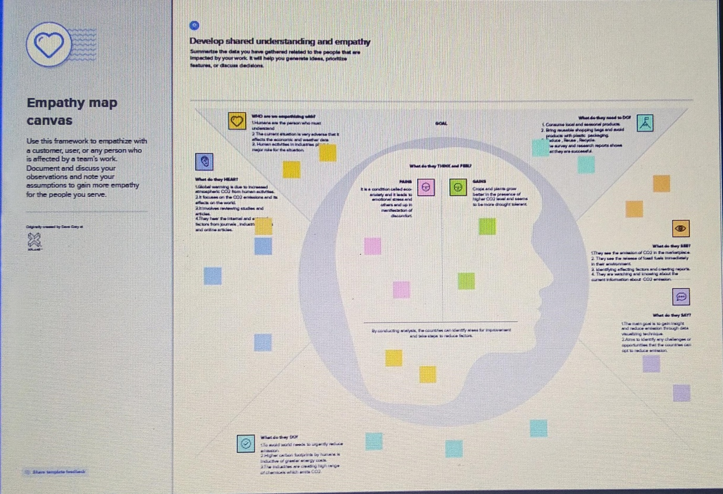

**2.2 IDEATION AND BRAINSTORMING MAP:**

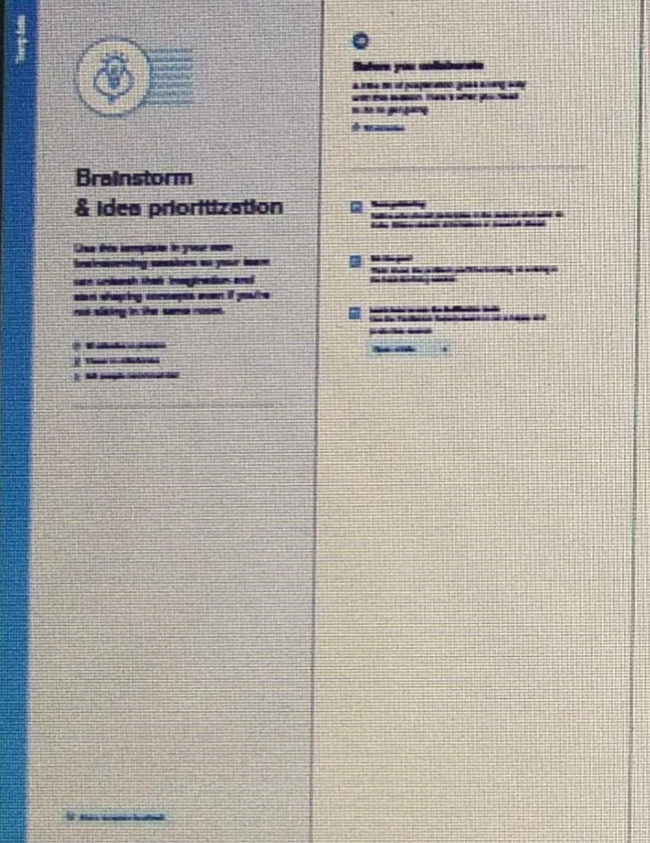

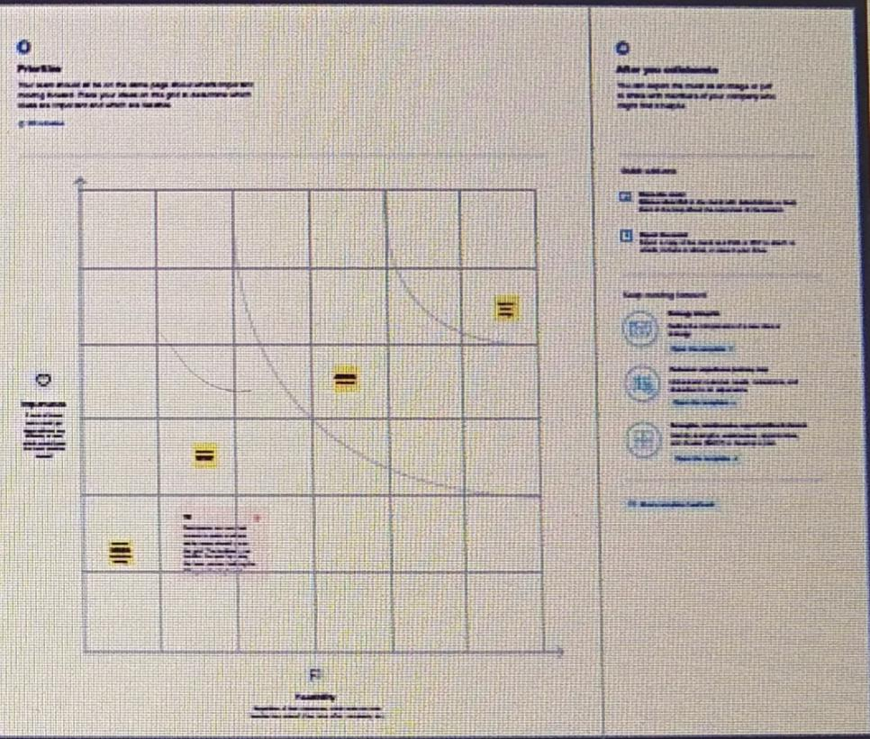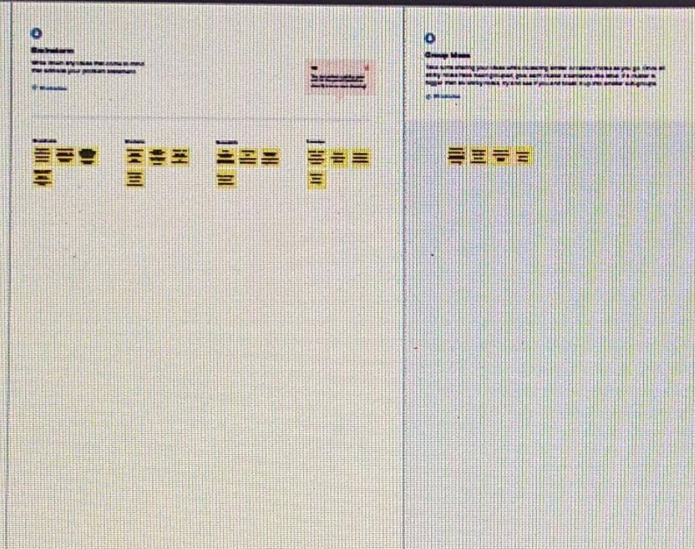

**3.RESULT**

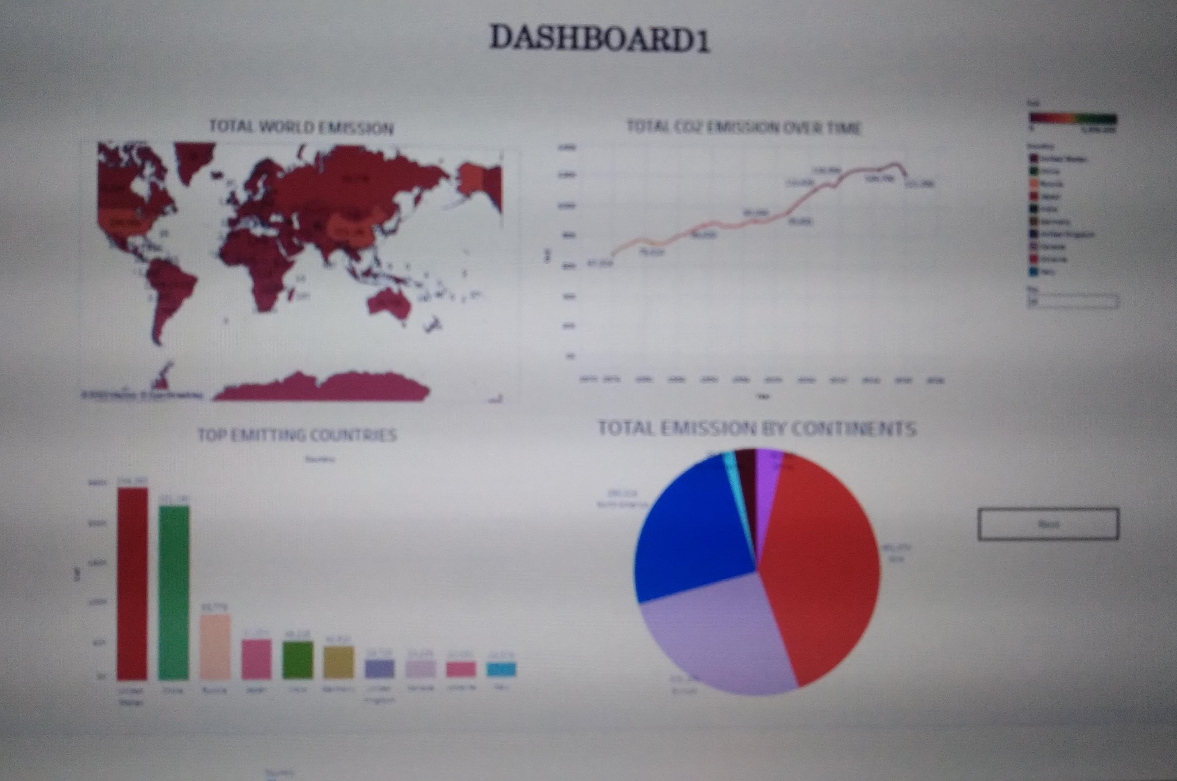

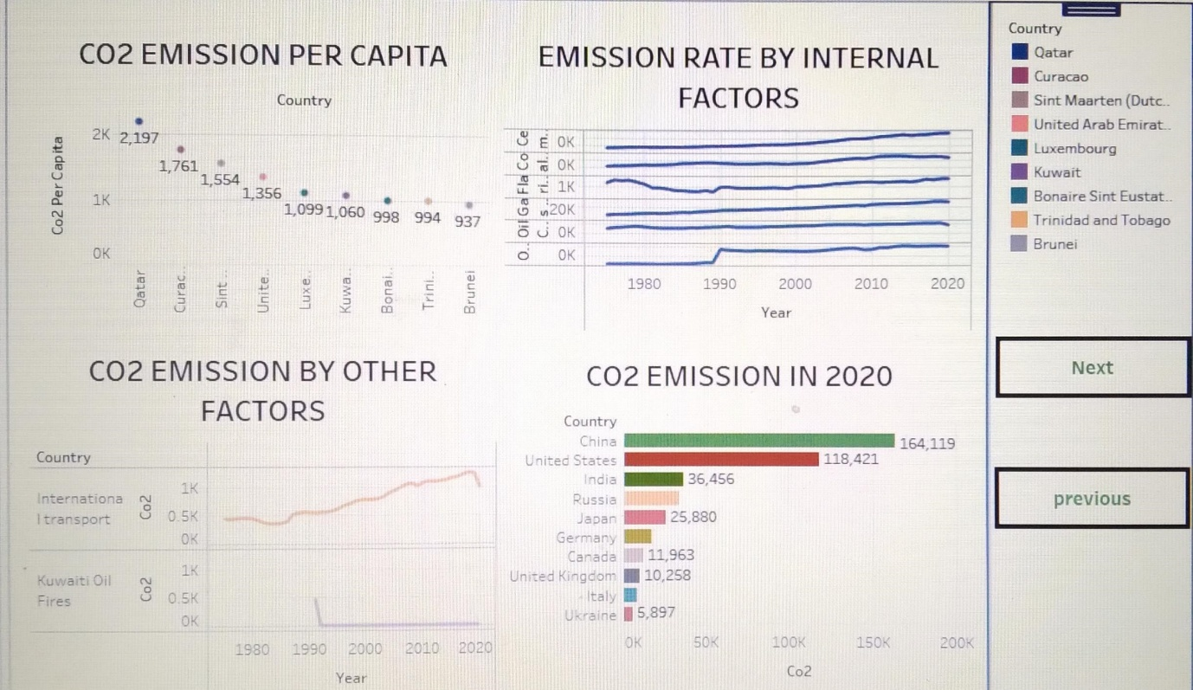

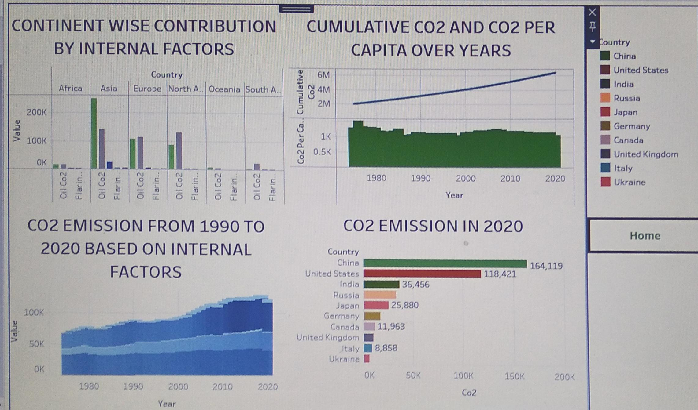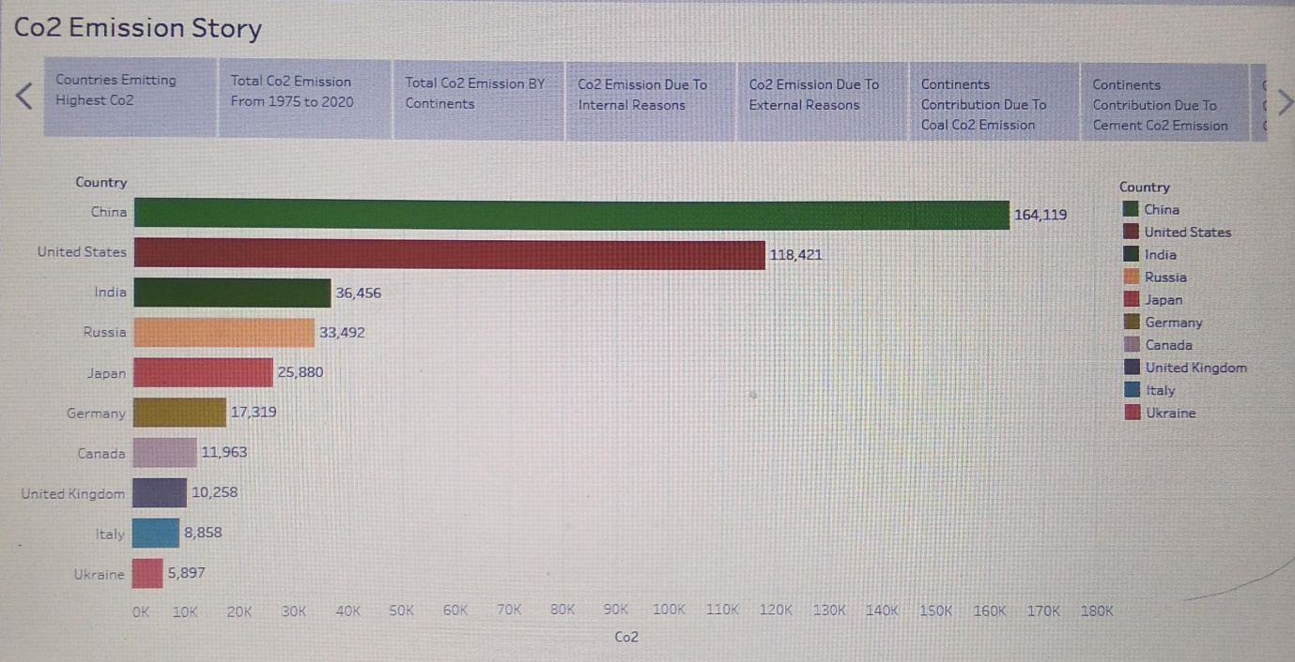

**4.ADVANTAGES**

Green plants grow faster with more CO2. Many also become more drought- resistant because higher CO2 levels allow plants to use water more efficiently. More abundant vegetation from increased CO2 is already apparent. Reducing Greenhouse Gas Emissions Can **Improve Air Quality and Save Lives**. Reducing global greenhouse gas emissions to slow climate change could prevent millions of premature deaths due to air pollution over the next century, according a new study funded by NIEHS.

**DISADVANTAGES**

CO2 emissions act like a blanket in the air, **trapping heat in the atmosphere, and warming up the Earth** . This layer prevents the Earth from cooling, and thus raises global temperatures. Global warming would affect environmental conditions, food and water supplies, weather pattern, and sea levels. The amount of carbon emissions trapped in our atmosphere causes global warming, which causes climate change, symptoms of which include melting of the polar ice caps, the rising of sea levels, the disturbance of animals' natural habitats, extreme weather events, and so many more negative side effects that are dangerous.

**5.APPLICATIONS:**

* CO2 can be used in the production of building materials to replace water in concrete, called CO2 curing, or as a raw material in its constituents (cement and construction aggregates).
* These applications involve the reaction of CO2 with calcium or magnesium to form low-energy carbonate molecules, the form of carbon that makes up concrete .
* The carbon (and oxygen) in CO2 can be used as an alternative to fossil fuels in the production of chemicals, including plastics, fibres and synthetic rubber. As with CO2-derived fuels, converting CO2 to methanol and methane is the most technologically mature pathway.

**6.CONCLUSION**

The rising level of atmospheric CO2 could be the one global natural resource that is progressively increasing food production and total biological output, in a world of otherwise diminishing natural resources of land, water, energy, minerals, and fertilizer. Without carbon dioxide, Earth's natural greenhouse effect would be too weak to keep the average global surface temperature above freezing. By adding more carbon dioxide to the atmosphere, people are supercharging the natural greenhouse effect, causing **global temperature to rise**.

**7.FUTURE SCOPE:**

CO2 can also **replace fossil fuels as a raw material in chemicals and polymers**. Less energy-intensive pathways include reacting CO2 with minerals or waste streams, such as iron slag, to form carbonates for building materials. The future market potential for CO2-derived products and services is difficult to assess.